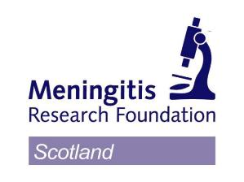
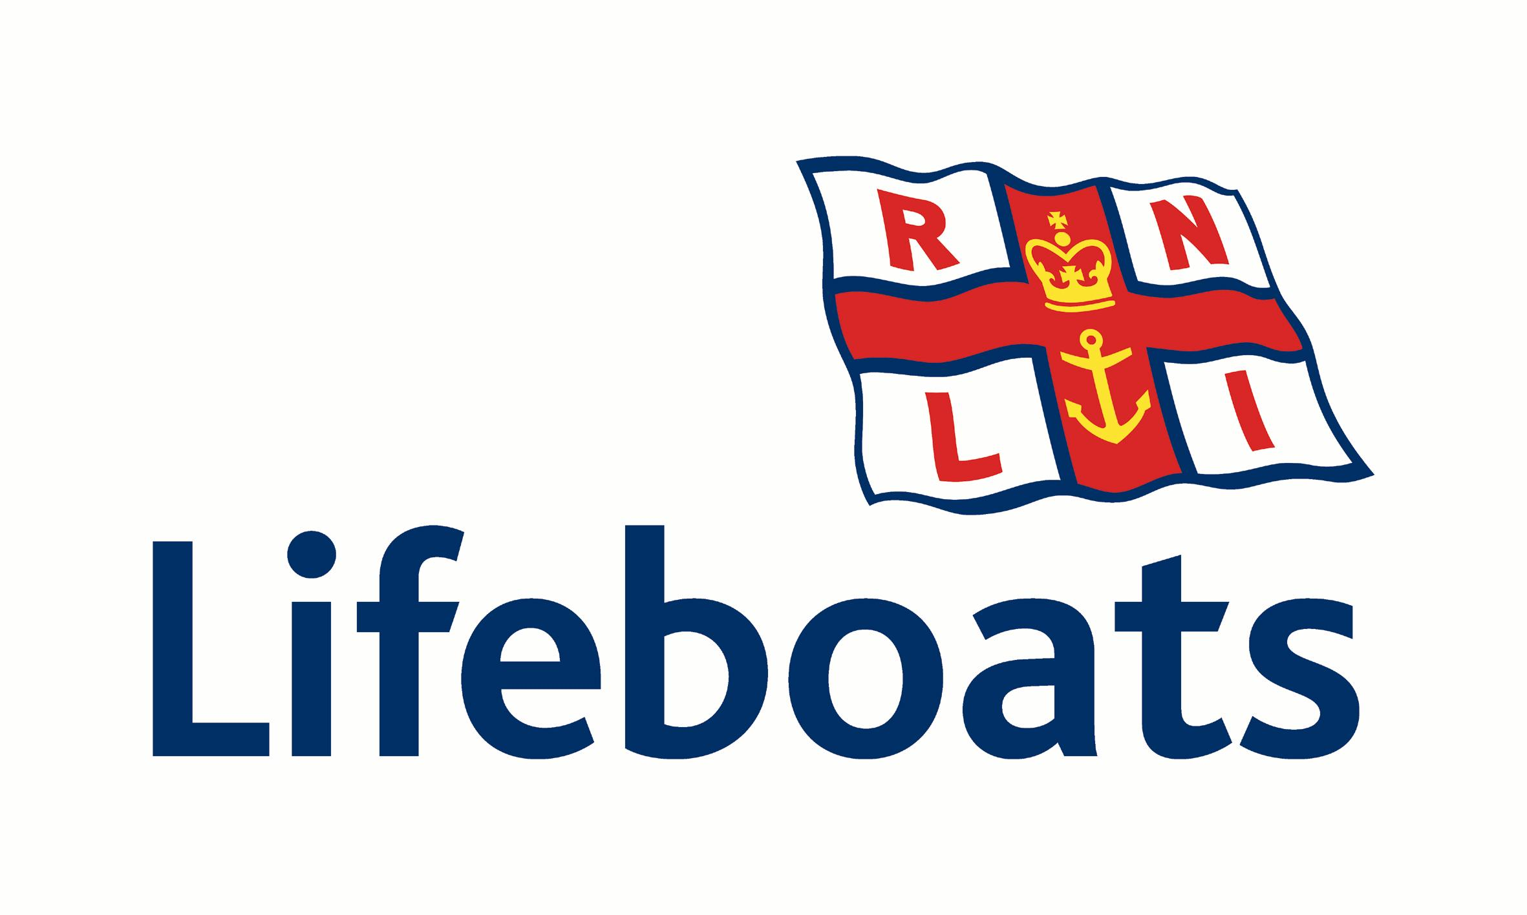
Meningitis Research Foundation
28 Alva Street
Edinburgh
EH2 4PY

Hold a Burns Super Supper in your own home
and raise money for charity
(all speakers and music supplied!)

In a joint venture, Meningitis Research Foundation (MRF) and the Royal National Lifeboat Institution (RNLI) have teamed up with ClanRadio to encourage people to host a Burns Night Super Supper in aid of charity on 25 January 2010. ClanRadio will broadcast the music and speeches – everything hosts need except food and friends to share it with.

All the elements of a Burns supper will be supplied via a broadcast from ClanRadio (www.clanradio.net) - from the initial Piping in of the Haggis through to Auld Lang Syne and will include the usual Toasts, the address to the Haggis, the Immortal Memory, The Lasses, singing, fiddle music, recitations, and a music filled interval during which hosts can serve the haggis and neeps and tatties. Permission for the use of all the music and songs has been given by the contributors to the broadcast.

Listeners to the Programme will hear a message from Mike Duguid, President of the Robert Burns World Federation, and no less that three Past World Presidents are involved. These include Peter Kormylo, a former President of the Dumfries Burns Howff Club, where the Bard himself took refreshment on more than one occasion. Peter will respond to the Toast to the Lasses. Giving a sparkling response on behalf of the Lasses will be Roberta Young who is a volunteer fundraiser with the RNLI and Murdo Morrison from ClanRadio who supports MRF.

The broadcast will be on-line on 25th January 2010. A pre-recorded CD is also available to those who want to get involved in this unusual initiative, but are unable to do so online or who wish to host a supper on an alternative evening.

A registration system is in place and a fee of £5 is being requested to cover costs. It is hoped that participants will raise a minimum of £50. Anyone raising more than £250 will receive a free bottle of whisky. On receipt of registration, full details, running order and fundraising resources will be provided.

Murdo Morrison contracted Meningitis when he was twenty years old and barely survived. He did so because of the early efforts in research, diagnosis and treatment of this deadly disease.

Roberta Young says: ‘The RNLI is a wonderful cause, which I was inspired to support after meeting local RNLI volunteers in Portpatrick and witnessing the lifeboat launching in horrendous conditions. I have also been passionate about Burns since I was a child and think it is a great idea for a Burns Night Supper to be a charitable event. I am very flattered to have been asked to respond on behalf of the Lasses and I hope all who listen in enjoy their Burns Super Supper’

Murdo Morrison from ClanRadio commented: ‘Burns Suppers have come a long way from the first one reputedly held in Burns Cottage in Alloway when a few of the many friends of the Bard assembled to partake in a supper and remember his life and contribution to the poetry and songs of Scotland. There are now over 400 Robert Burns Clubs throughout the world.’

Mary Millar from MRF and Ann Gordon from RNLI commented: ‘Already there are hosts volunteering their services to take part, provide a location in homes and clubs and raise vital funds for our respective causes. Both our charities rely on events such as this and the fund raising efforts of our supporters to maintain our services.’

Contact the charity of your choice for further information:

Meningitis Research Foundation: Dawn Carrie, tel 0131 510 2345, email dawncarrie@scotland-meningitis.org.uk

Royal National Lifeboats Institution: Ann Gordon, tel 01738 642999, email scotland@rnli.org.uk

ENDS 31 July 2026

Media Contacts:

Meningitis Research Foundation: Mary Millar, Scotland Manager on 0131 510 2345 or at marymillar@scotland-meningitis.org.uk

RNLI: Rachel Martin, Media Relations Manager (Scotland) on 07786 668903 or at
rachel_martin@rnli.org.uk

Clan Radio: Murdo Morrison on 01698 372638 or at
murdomorrison13@blueyonder.co.uk

Notes to Editor:

Meningitis Research Foundation
- Meningitis Research Foundation is currently funding 24 research projects into the prevention, detection and treatment of meningitis and septicaemia. The Foundation has spent £15.6 million on research since its inception in 1989.
- Meningitis Research Foundation operates a Freefone 24 hour helpline – 080 8800 3344 – providing information on meningitis and septicaemia to the general public and health professionals.
- Information on meningitis and septicaemia is also available on the Foundation’s world-renowned website – www.meningitis.org – in 22 languages. An interpretation service in 150 languages is available through the 24-hour helpline.
- The Foundation offers support for those affected by meningitis and septicaemia. Trained helpline staff are available 365 days a year. A befriender service links people with experience of meningitis and septicaemia to share their experiences and counsel each other.

RNLI
- The RNLI charity saves lives at sea. Its volunteers provide a 24-hour search and rescue service around the United Kingdom and Republic of Ireland coasts. The RNLI operates over 230 lifeboat stations in the UK and Ireland and has more than 140 lifeguard units on beaches around the UK. The RNLI is independent of Coastguard and government and depends on voluntary donations and legacies to maintain its rescue service. A charity registered in Scotland (SC037736) and England and Wales (209603). Charity number CHY 2678 in the Republic of Ireland. For more information visit www.rnli.org.uk or call 01738 642999.

The broadcast is being made possible with the help of:
- Inner Ear (innerear.co.uk) and the Wishaw and District Talking Newspapers
- Robert A MacKenzie of clanradio.net produced the Burns Super Supper, in collaboration with Murdo Morrison of Radio Mod.

